**Physiological Instrumentation**

Purpose: to get familiar with the lab equipment

Procedure:

* for linear measurements section, I measured my notebook with a ruler
* for volumetric and mass measurements sections, I first weighed the beaker to get the weight without water so I can simultaneously do two parts that involved putting water in the beaker and then poured the water into the graduated cylinder after weighing out the beaker with the water
* for pH measurements section, dropped pieces of pH measuring paper into the separate liquids
* for time measurements section, after a few mess ups, used my index and middle fingers feel the blood passing in the carotid artery in my neck

Results: (see next page)

Discussion: doesn’t seem very complicated to use any of the lab equipment so long as the instructions are followed

Conclusion: learned how to use basic lab equipment and what way they measure

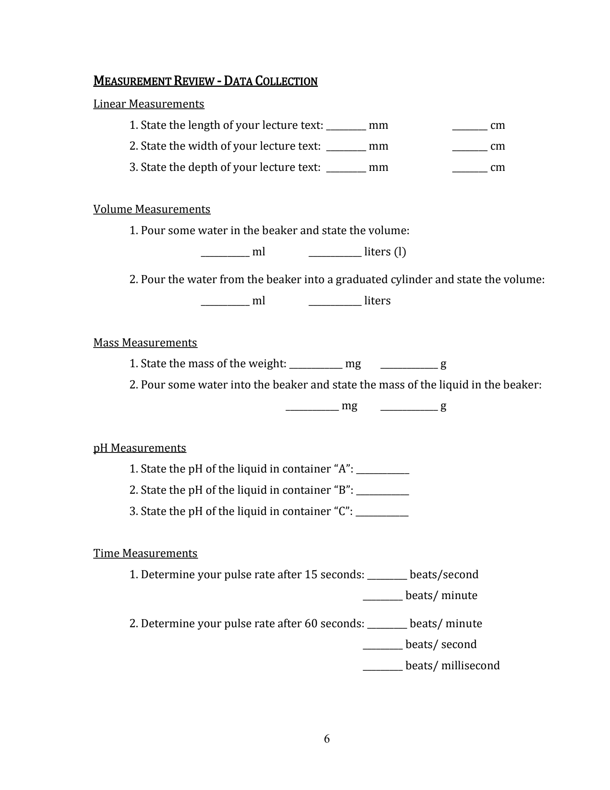

66

70

68

9

7

.075

75

.066

2

22.5

28

.0012

1.1667

1.1334

3

65,050

65.05

5

5000

20

280

225